Render

[ktpm3-web.onrender.com](https://ktpm3-web.onrender.com/)

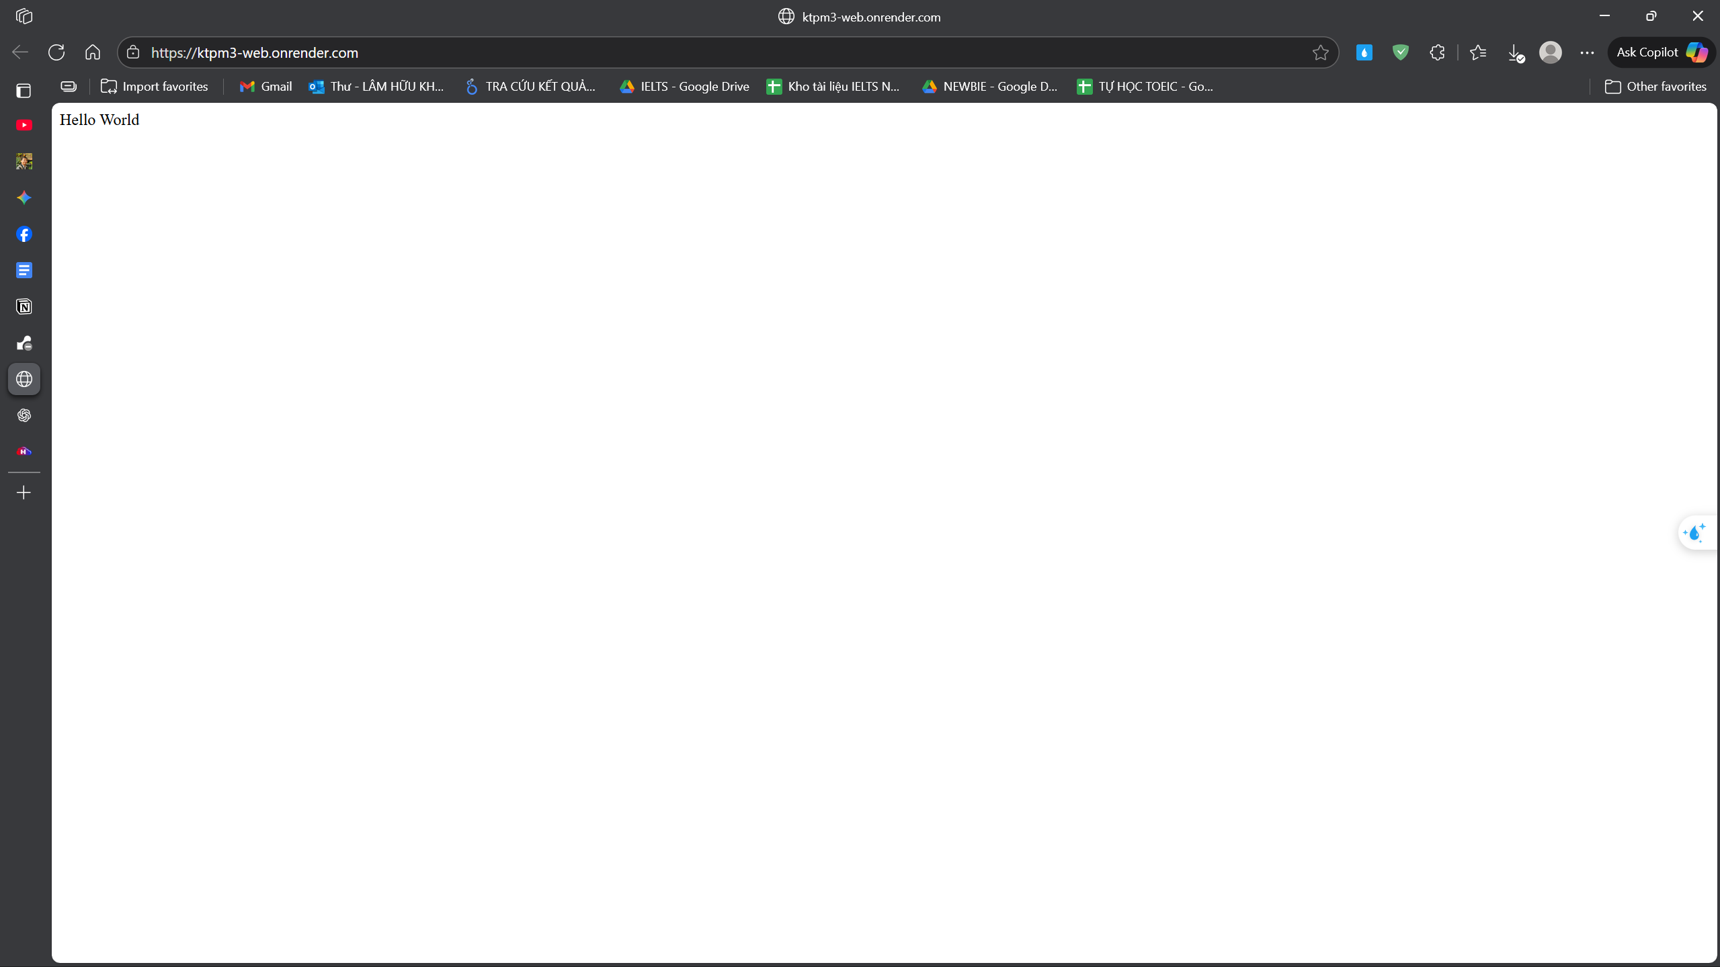

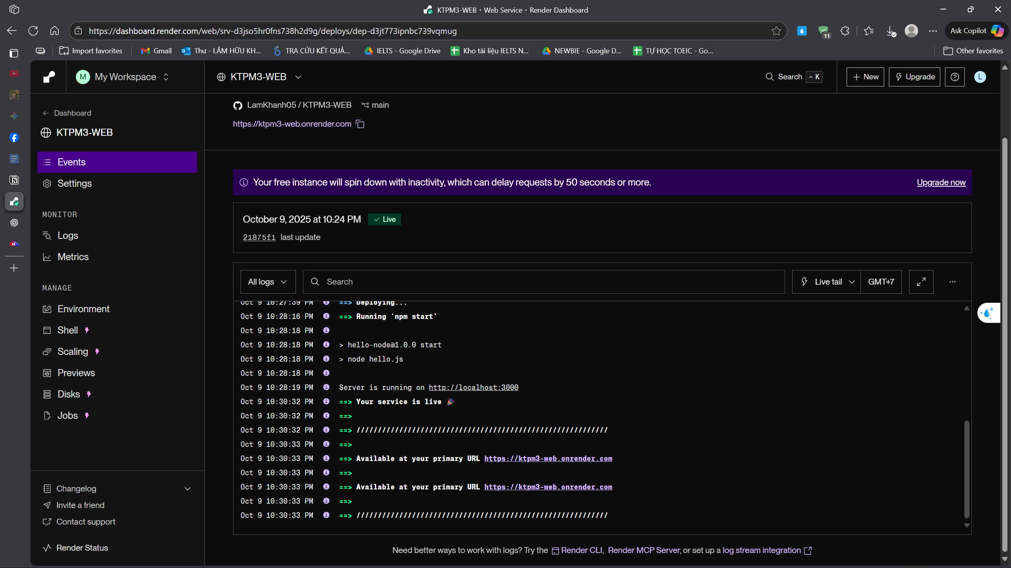

Railway

[ktpm3-web-production.up.railway.app](https://ktpm3-web-production.up.railway.app/)





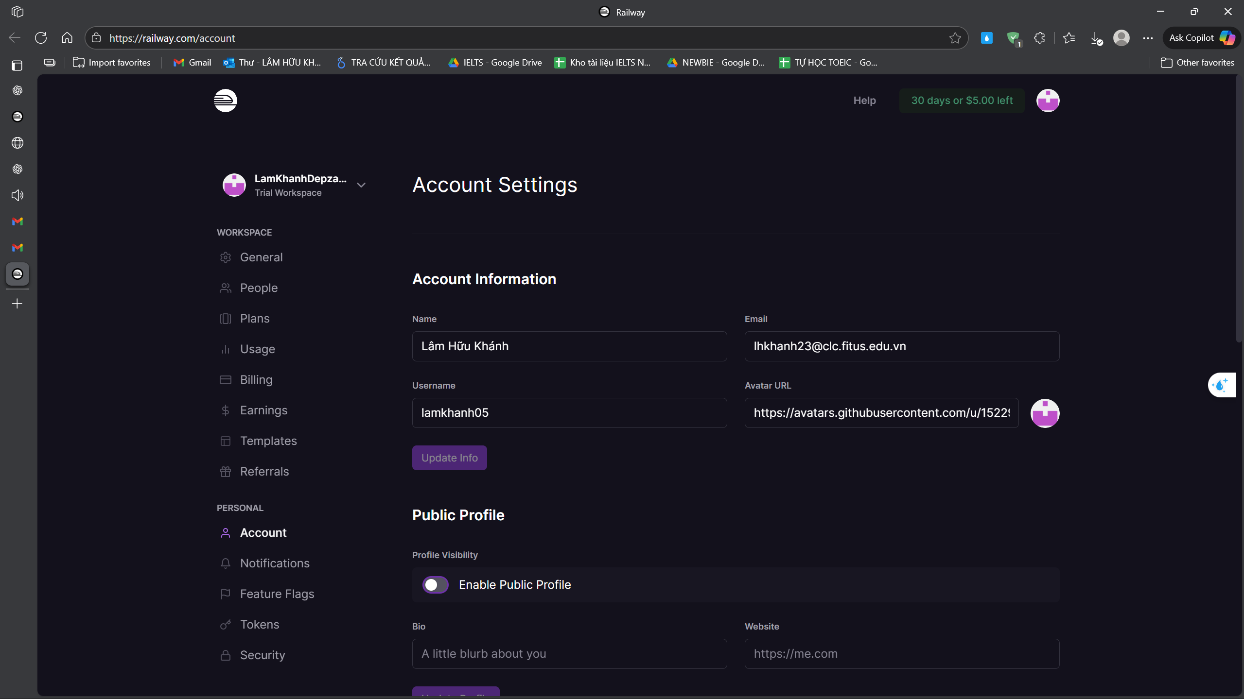

Vercel

